This article focuses on two critical issues that machine learning professionals may encounter in real-world circumstances. The first relates to the many types of accessible input information that an agent may observe, while the second refers to the models for learning and selecting optimum behaviours that are chosen (and improved). The following Atari game will be the topic of this task: – (Asterix) In order to gather cauldrons and dodge the lyres, the player must steer Asterix between the stage lines.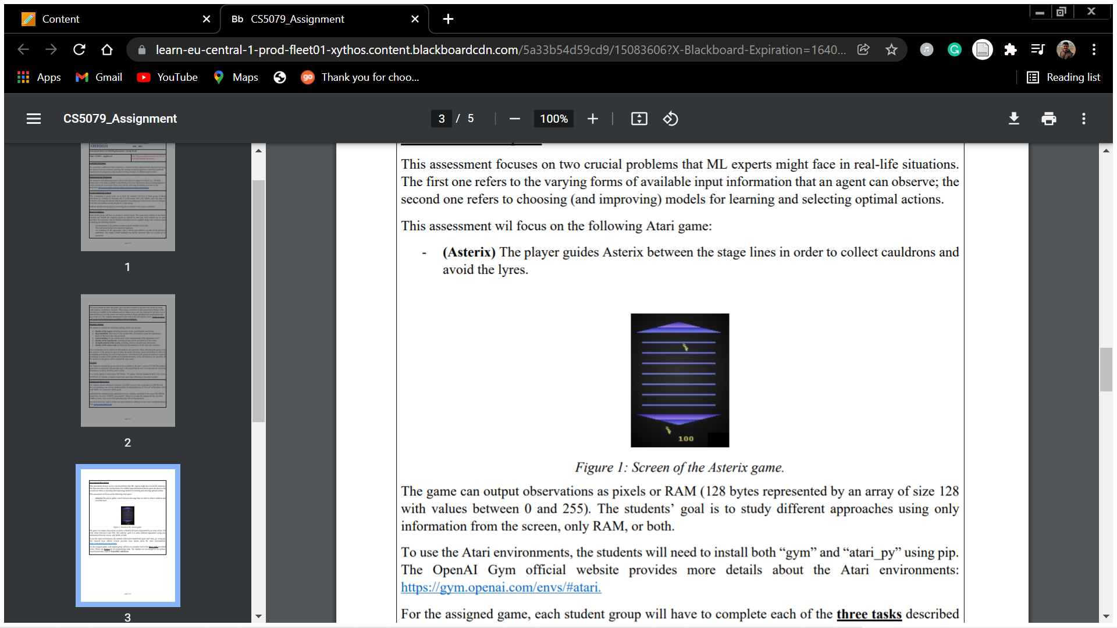

Figure 1: Screen of the Asterix game.

The game can output observations as pixels or RAM (128 bytes represented by an array of size 128 with values between 0 and 255). The students’ goal is to study different approaches using only information from the screen, only RAM, or both. To use the Atari environments, the students will need to install both “gym” and “atari_py” using pip. The OpenAI Gym official website provides more details about the Atari environments: https://gym.openai.com/envs/#atari.